**Lesson 9**

* Today’s lesson activities will be done autonomously while I call you to do the speaking practice with me.
* Please, use **vocabulary** from unit 8 in your book and try to use **passive** and **causative** structures when possible.
* Check the list of **connectors** and other useful expressions to **make reference** to the information on the video or what another person has said.
* Do the activities on this document and upload it on POLIFORMAT – TAREAS.
* Deadline: During today’s class time

**Practice 9 – Globalisation**

**1. Watch the video about globalisation and answer the questions.**

**Listening – (This task will be part of your evaluation)**

*You’re going to watch a video about* ***globalisation.*** *Watch the video just twice. The first time, try to understand the main idea*.

**After watching the video the first time, how would you explain what globalisation is?**

**Globalisation is a concept that refers to the possibility of communicating and being in contact easier and faster. Also it affects the global economy and many other areas**

*Now watch the video de second time. This time make some notes as you listen. Then I’ll ask you to tell me what the* ***pros*** *and* ***cons*** *of globalisation are according to the video. Try to make notes on as many examples as you can. Are you ready?*

**Advantages**:

* It is easier to exchange information among other people.
* Globalisation allows you to move quickly between countries.
* Also, Globalisation offers products with lower prices.
* It creates more competition among companies with the possibility of improving.

**Disadvantages**:

* In some countries which salary is higher than other countries, people lose their jobs.
* Globalisation also affects climate change due to the greater use of polluting means of transport
* At the same time, the environment is being destroyed to make factories.

Record a **2-MINUTE FLIPGRID** in which you summarise **what globalisation is about** and the **advantages** and **disadvantages** mentioned in the video. Then, **give your opinion** on whether globalisation has improved our world or has worsened it. I’ll stop you after 2 minutes.

**Speaking Topic 9**

**PART 1. Watch these videos in your chat room and answer the question:**

* The 2 euro T-shirt – A social experiment

<https://www.youtube.com/watch?v=KfANs2y_frk&ab_channel=FashionRevolution>

* The true cost – Official Trailer

<https://www.youtube.com/watch?v=OaGp5_Sfbss&ab_channel=Untold>

What do you think of this experiment? What would you have done?

**It is a very interesting experiment; however, it is true that they are on the street and some people want to seem empathic, but they are not really. At the same time, the video only shows people how chose to donate, maybe it would have been better to show a statistic in the final.**

**Without a doubt, I would have chosen “donate”, it is impermissible to work that way.**

Why is the current business model unsustainable? What can be done to improve it?

**Because there are many people being exploited behind all the clothes that reach other countries.**

**We could offer them a fair salary, or stable living conditions.**

**PART 2. Watch these videos in your chat room and answer the questions:**

* Global citizenship is… <https://www.youtube.com/watch?v=XVSgbU6WVSk&ab_channel=UNESCO>

What is a global citizen to you? Do you consider yourself a global citizen? Do you think we should become ‘global citizens’? Why / Why not?

**PART 3. Discuss these questions:**

* How does globalisation affect the food you eat? The products you buy?

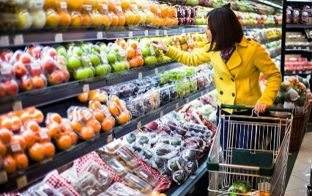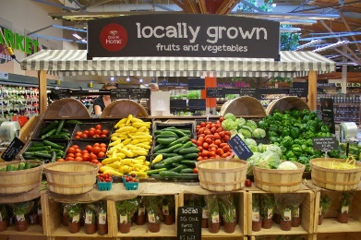

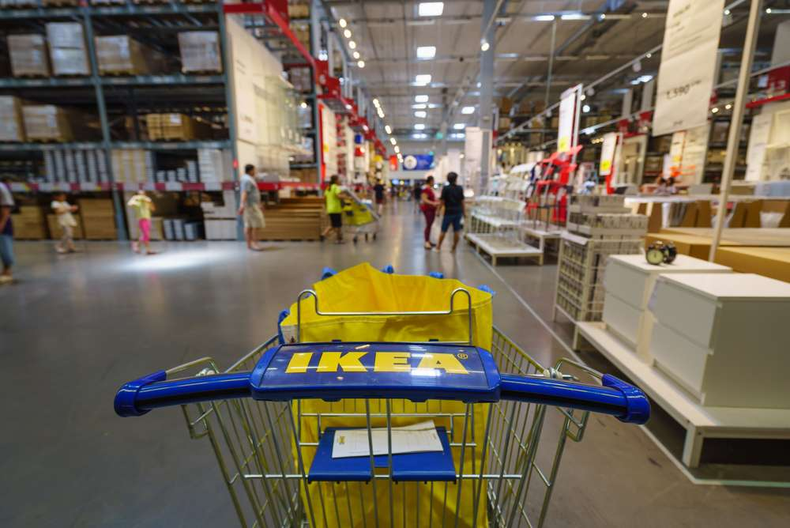

* How would your life be different if globalisation hadn’t happened? What type of things wouldn’t you be able to do?
* 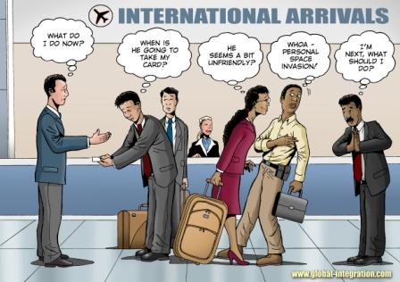How does globalisation affect jobs?
* Do you think globalisation will make us all the same in the future?
* Do you think globalisation could end in a world with just one giant country?
* Do you think globalisation will reduce or increase the poverty gap?
* How do you

Record a **5-minute** video in which you discuss the positive and negative effects of globalisation and how you think this will affect us in the future.

**Extra:**

* If the world were 100 people: <https://www.youtube.com/watch?v=QFrqTFRy-LU&ab_channel=GOODMagazine>

**This is just a curious video to think about the position you occupy in the world.**